**Innothule Swamp**

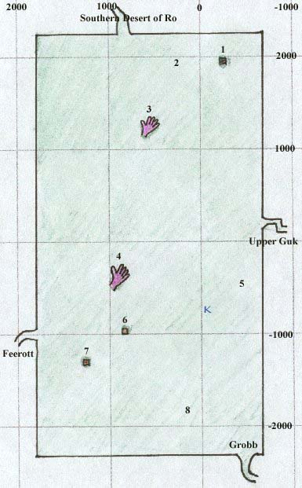

* 1. Tower, Home of [Jojongua](https://wiki.project1999.com/Jojongua" \o "Jojongua) and Fetid Froglok Ghouls
* 2. High level monsters (froglok foragers and kobold hunters)
* 3. Stone Hand where shaman spell vendor [Stragak](https://wiki.project1999.com/Stragak" \o "Stragak) is located
* 4. Stone Hand with shadowmen (-430, 980)
* 5. Froglok Hunting Grounds
* 6. Ruined Ferry
* 7. Submerged Hut
* 8. Newbie Area